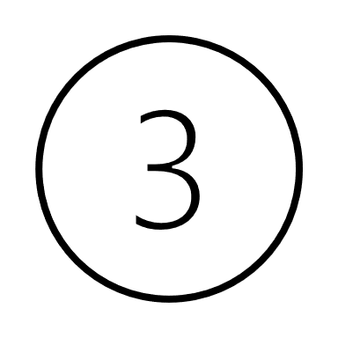
Part 2 6U(T Ball)
- Pre Game:
  - coaches distribute cones in 3 areas
  - Hand sanitizer on each bench
- Players socially distanced
  - LF line, RF line or both benches
  - Encourage players to bring folding chairs
  - Meet with coaches and go to first game area

- Game Format 6:30 pm-7:30 pm
APPROX. TIMES BATTING > OUTFIELD > INFIELD >
6:30-6:40 pm Team 1 Team 2 Team 3
6:40-6:50 pm Team 3 Team 1 Team 2
6:50-7:00 pm Team 2 Team 3 Team 1
7:00-7:10 pm Team 1 Team 2 Team 3
7:10-7:20 pm Team 3 Team 1 Team 2
7:20-7:30 pm Team 2 Team 3 Team 1
- Players bat and all runners advance 1 base.
- If out is made, still advance to 1B
- When each batter has batted 1 time (or 2 depending on numbers) rotate
- Rotation is initiated by batting team
- Sanitize hands when team gets to batting station
- Should get through rotation twice per game

- Drill schedule
  - When team is in outfield they do drills lead by coach and assistants.
  - Minimize sharing of equipment…sanitize between uses if sharing
  - 2 different drills per night, but drills can be repeated different weeks
    - Week 1: 6U ground ball drill/ 6U whiffle ball batting drill
    - Week 2: 6U whiffle ball batting drill/ 6U catching drill
    - Week 3: 6U catching drill/6U ground ball drill
    - Week 4:
    - Week 5:

